**DAILY ONLINE ACTIVITIES SUMMARY**

|  |  |  |  |  |  |  |  |
| --- | --- | --- | --- | --- | --- | --- | --- |
| **Date:** | 04-06-2020 | | | | **Name:** | Gudugunti Anirudh | |
| **Sem & Sec** | IV - A | | | | **USN:** | 4AL18CS023 | |
| **Online Test Summary** | | | | | | | |
| **Subject** | | Microcontroller and embedded systems | | | | | |
| **Max. Marks** | | 20 | | **Score** | | 16 | |
| **Certification Course Summary** | | | | | | | |
| **Course** | Python for Machine learning | | | | | | |
| **Certificate Provider** | | | Greatlearning.in | **Duration** | | | **2 hr** |
| **Coding Challenges** | | | | | | | |
| **Problem Statement:** 1: write a java program to read three integer values from the keyboard and find the sum of the values. Declare a variable "sum" of type int and store.  Problem 2: (using C++) Write a C++ program to find the missing number in array. | | | | | | | |
| **Status:** Completed | | | | | | | |
| **Uploaded the report in Github** | | | | yes | | | |
| **If yes Repository name** | | | | https://github.com/alvas-education-foundation/anirudh_gudugunti/tree/master/daily_progress | | | |
| **Uploaded the report in slack** | | | | yes | | | |

**Online Test Details**: MES test was scheduled from 02:00pm to 2:30pm. The portion for the IA was 3rd module there were 20 questions and the time assigned was 30minutes the questions were MCQ type. I scored 16/20.

**Snapshot**:

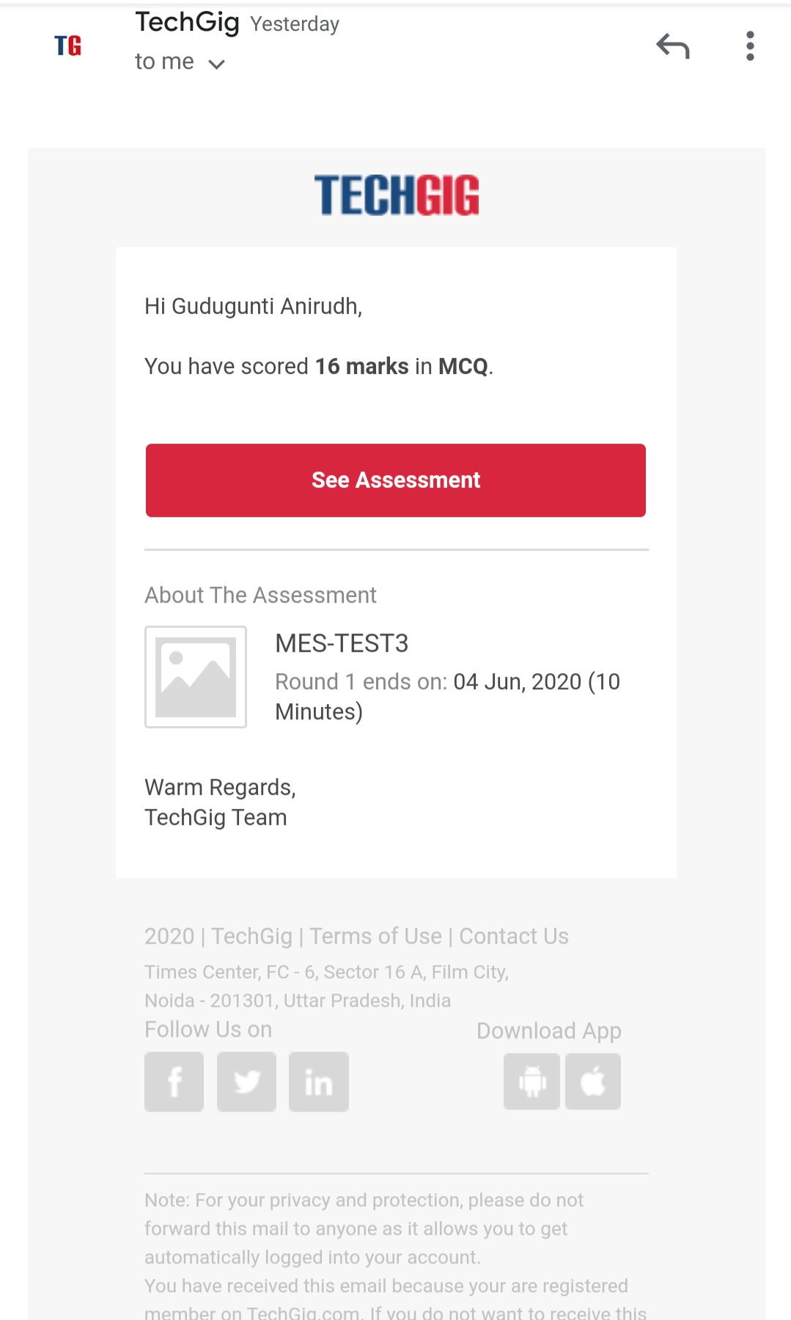

Certification Course Details:

1. Detailed instructions on class and objecs in python.

2. Class is a blueprint to create an object.

3. Examples on class and objects.

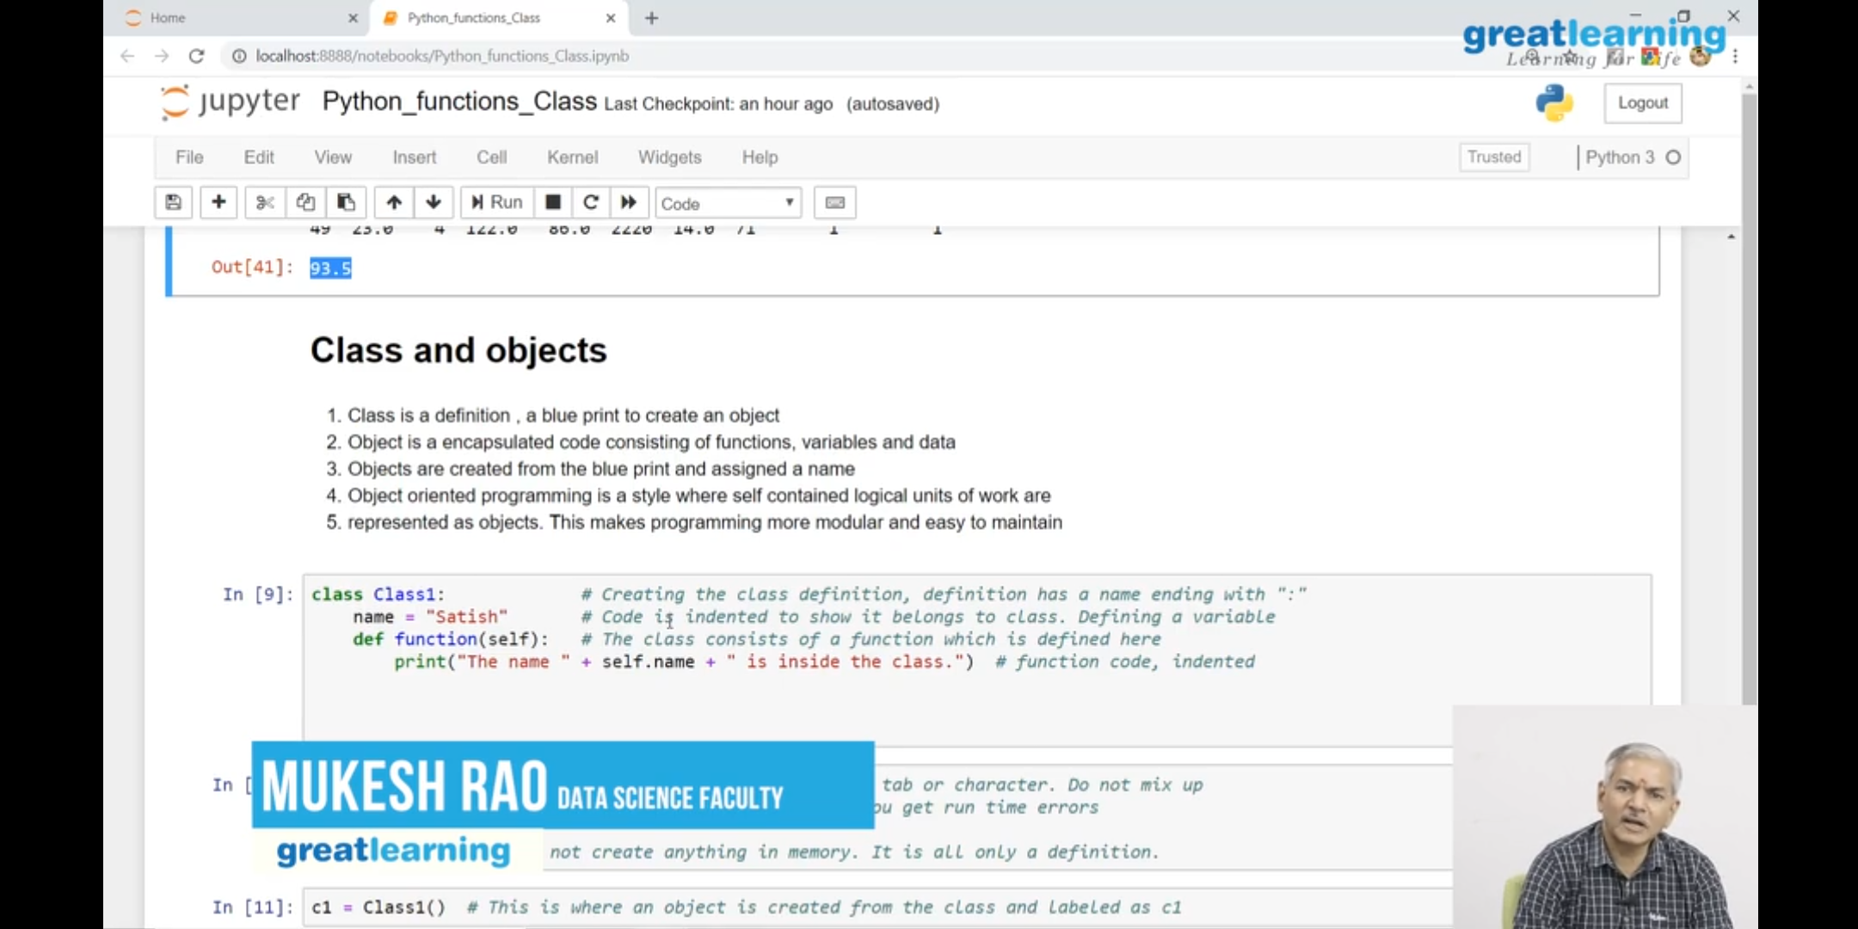

Coding Challenges Details:

Problem 1: (using Java) write a java program to read three integer values from the keyboard and find the sum of the values. Declare a variable "sum" of type int and store the result in it.

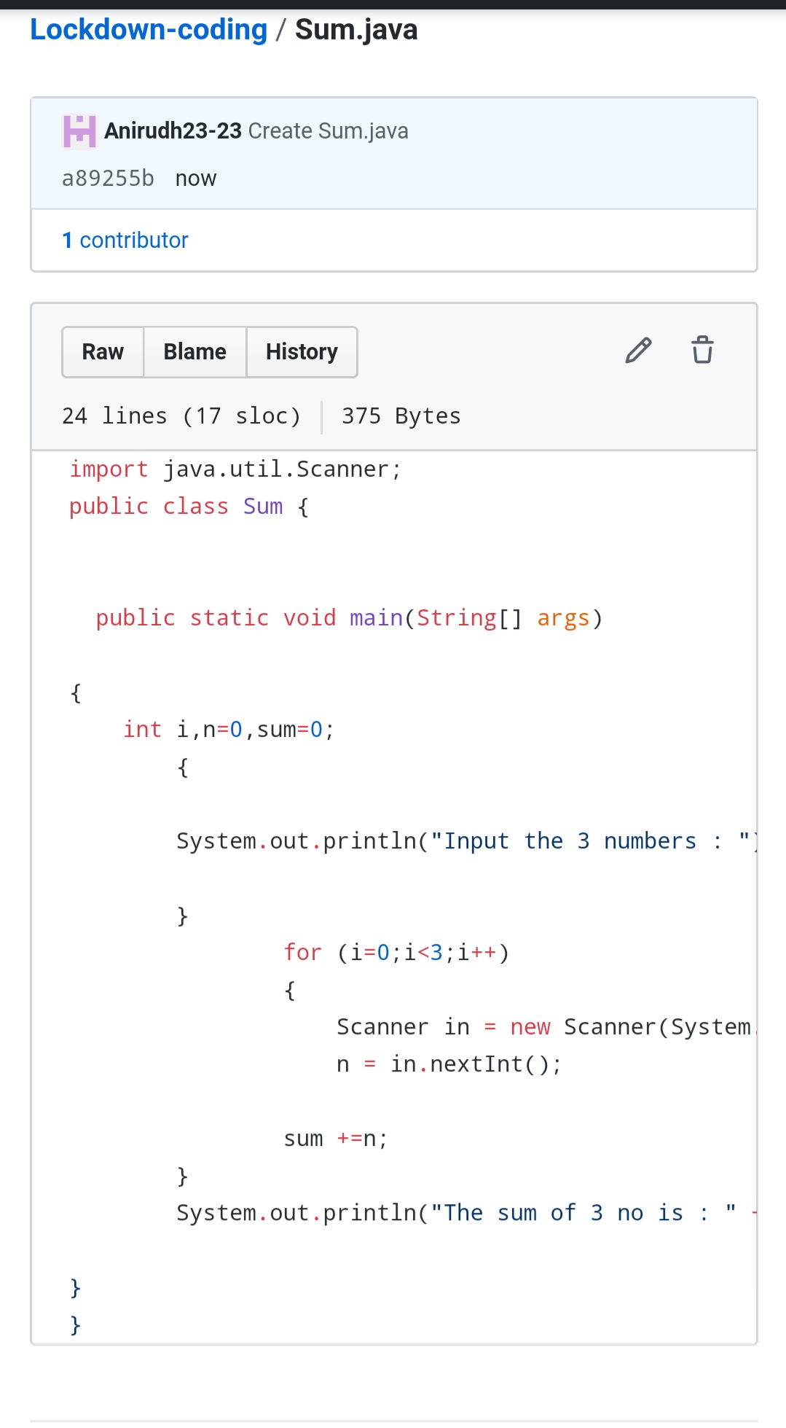

Problem 2: (using C++) Write a C++ program to find the missing number in 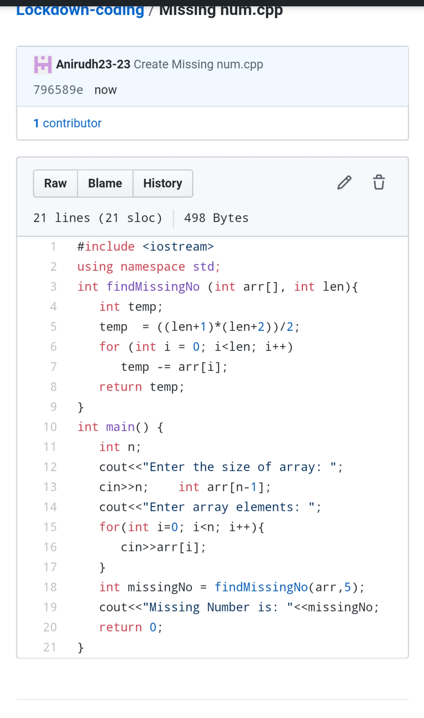array.